**Experiment No.: 8**

**Aim**

Naïve Bayes

**Questions**

Naïve Bayes With CSV

**Program and Output**

1. #upload,read,print csv file

import pandas as pd

import io

from google.colab import files

uploaded = files.upload()

df1=pd.read_csv('/content/golf-dataset.csv')

print(df1)

**Output**

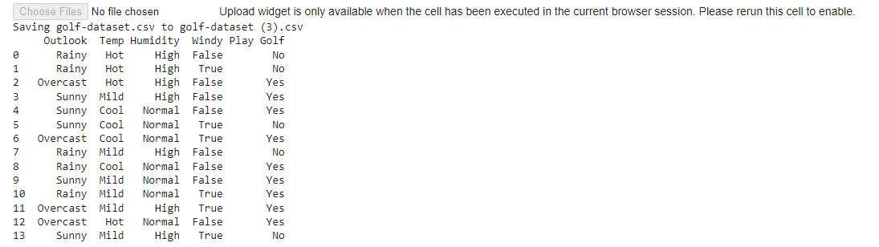

2. #replace attributes in csv

df1['Outlook'].replace(['Rainy'],[0], inplace=True)

df1['Outlook'].replace(['Overcast'],[1], inplace=True)

print(df1)

output

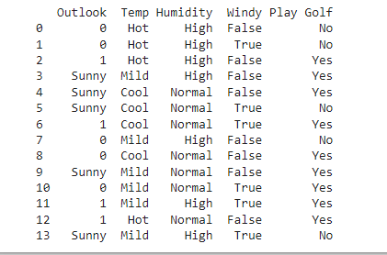

3.

import pandas as pd

import io

from sklearn.model_selection import train_test_split

df1.head(10)

X = df1.iloc[:, [0,1,2, 3]].values

y = df1.iloc[:, -1].values

print(X)

print(y)

X_train, X_test, y_train, y_test = train_test_split( X, y, test_size = 0.2, random_state=42)

print(X_test)

**Output**

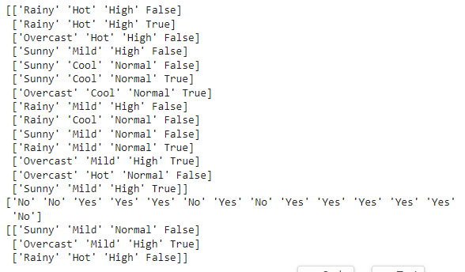

4.

a. # confusion matrix

import pandas as pd

import numpy as np

from sklearn import preprocessing

data= pd.read_csv('golf-dataset.csv')

label_encoder = preprocessing.LabelEncoder()

data['Outlook']= label_encoder.fit_transform(data['Outlook'])

data['Temp']= label_encoder.fit_transform(data['Temp'])

data['Humidity']= label_encoder.fit_transform(data['Humidity'])

data['Windy']= label_encoder.fit_transform(data['Windy'])

data['Play Golf']= label_encoder.fit_transform(data['Play Golf'])

data

**output**

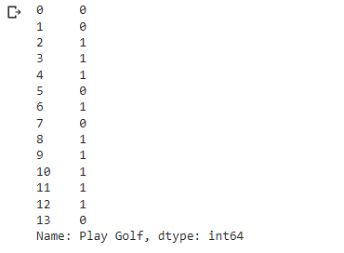

b.

X=data.drop('Play Golf', axis=1)

Y=data['Play Golf']

Y

**Output**

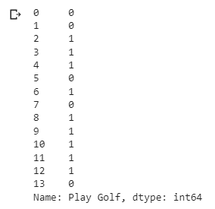

c.

from sklearn.model_selection import train_test_split

X_train, X_test, y_train, y_test = train_test_split(X, Y, test_size=0.1, random_state=42)

from sklearn.naive_bayes import GaussianNB

gnb = GaussianNB()

gnb.fit(X_train, y_train)

y_pred = gnb.predict(X_test)

from sklearn import metrics

print("Gaussian Naive Bayes model accuracy(in %):", metrics.accuracy_score(y_test, y_pred)*100)

**output**



d. from sklearn import metrics

confusion_matrix = metrics.confusion_matrix(Y, Y)

confusion_matrix

**output**

